**Game Physics Slide CA**

**By Daniel Foth and Lauren McGowan**

**Worked Example 1**

This example contains one object sliding down a plane. The new positions and velocities are calculated using Runge-Kutta 4.

**Worked Example 2**

This example contains two objects sliding down a plane. This time, the positions and velocities are calculated using Euler’s Method.

**Worked Example 3**

This example contains one object sliding down a plane. In this example, we demonstrated what happens when the friction is static, meaning the acceleration is 0 and the object is not moving.

**Conclusion**

Our results from the worked examples match the ones we get from our program which proves that our program works correctly.

**Example 1:**

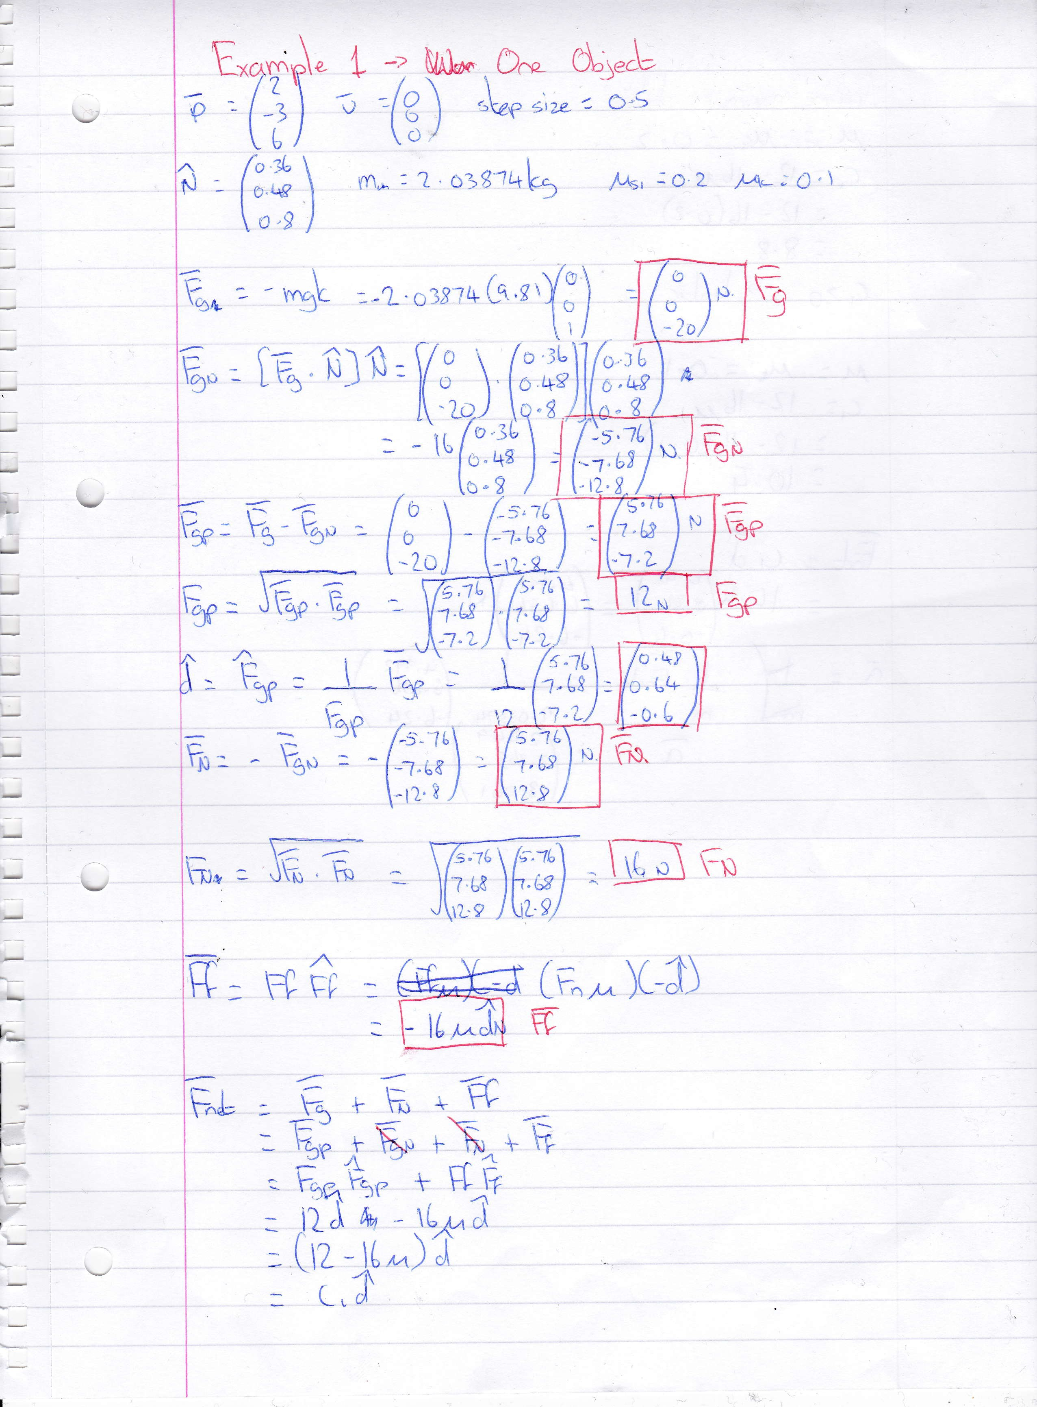

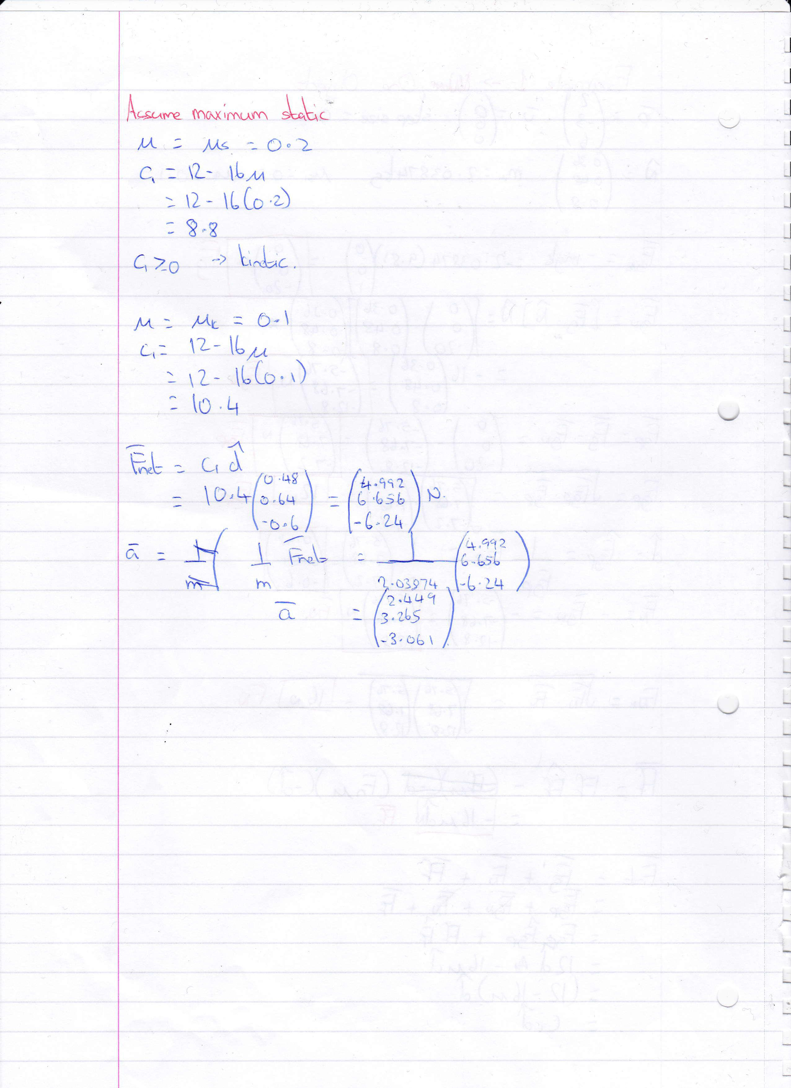

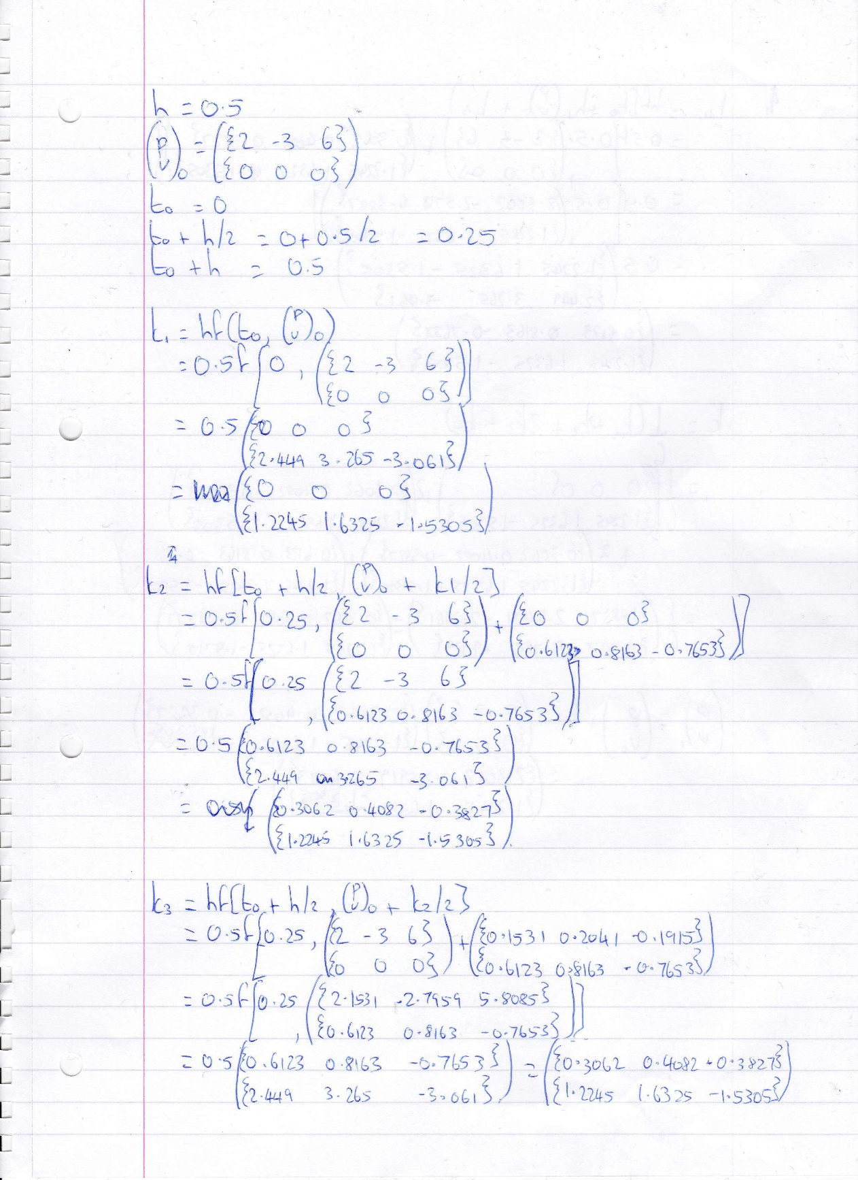

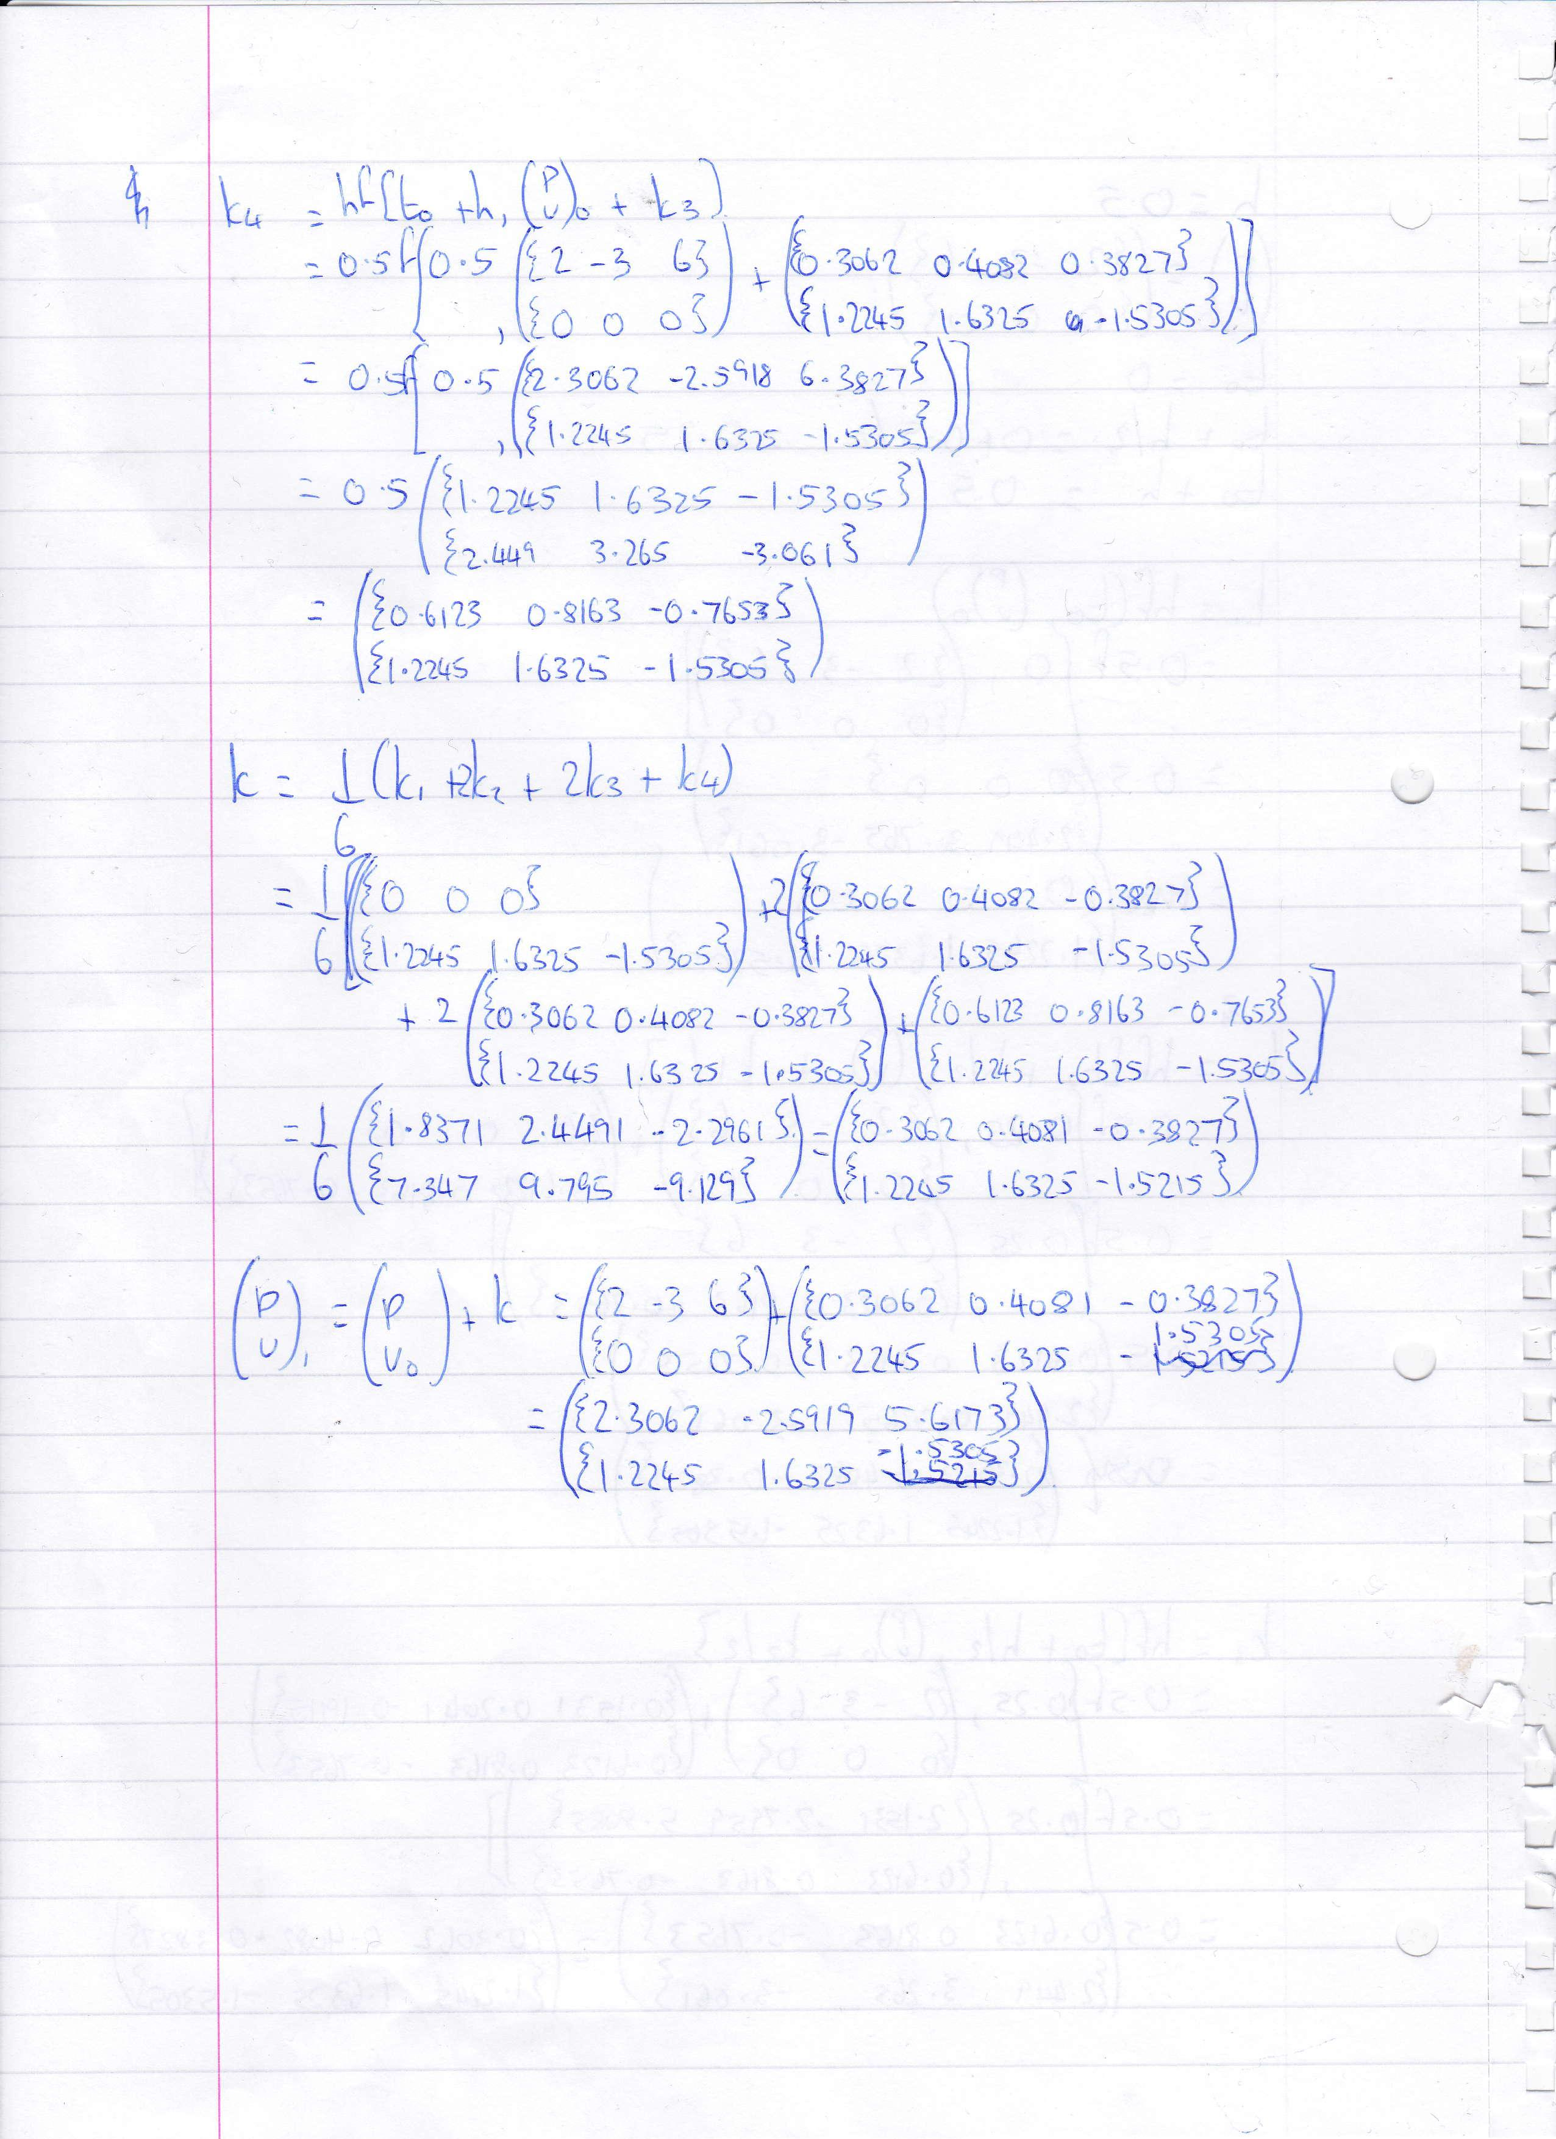

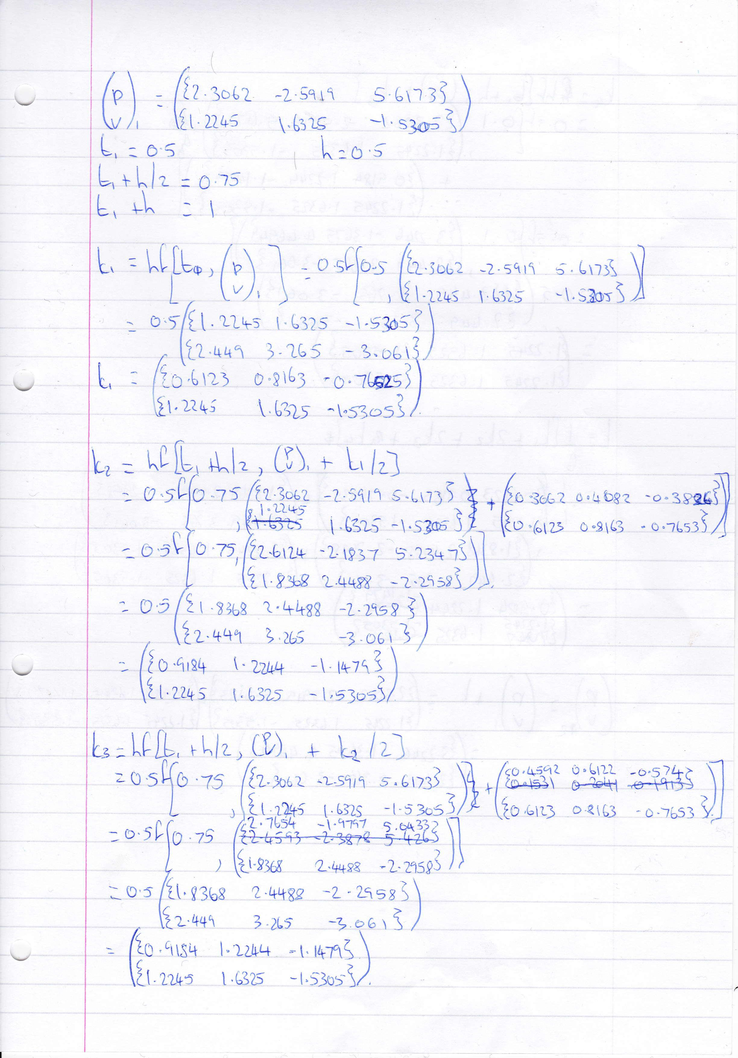

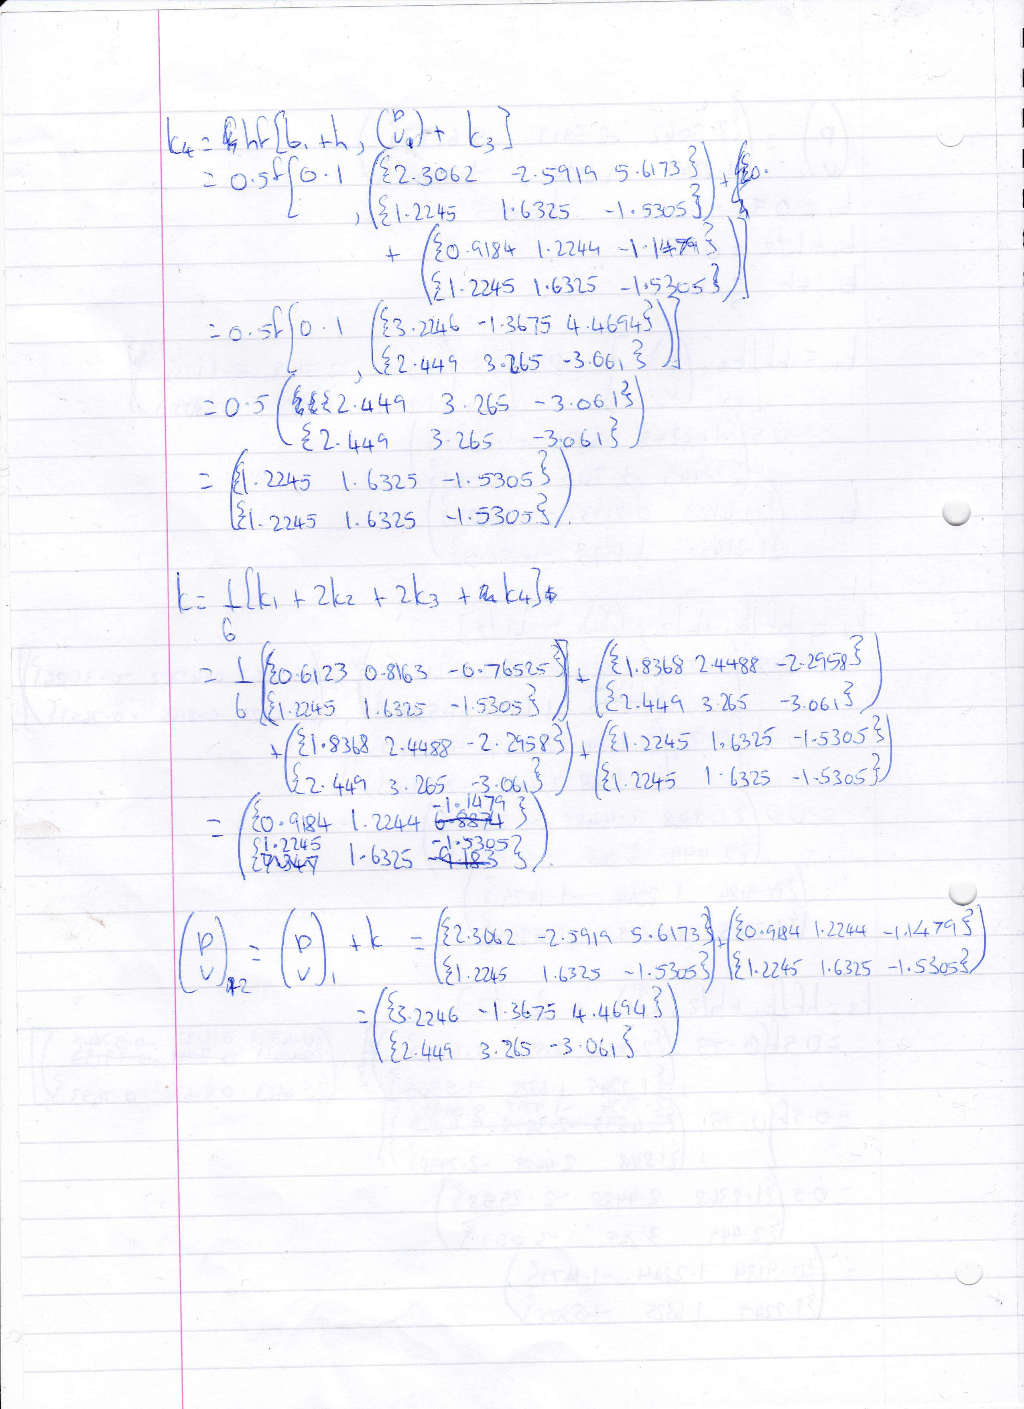

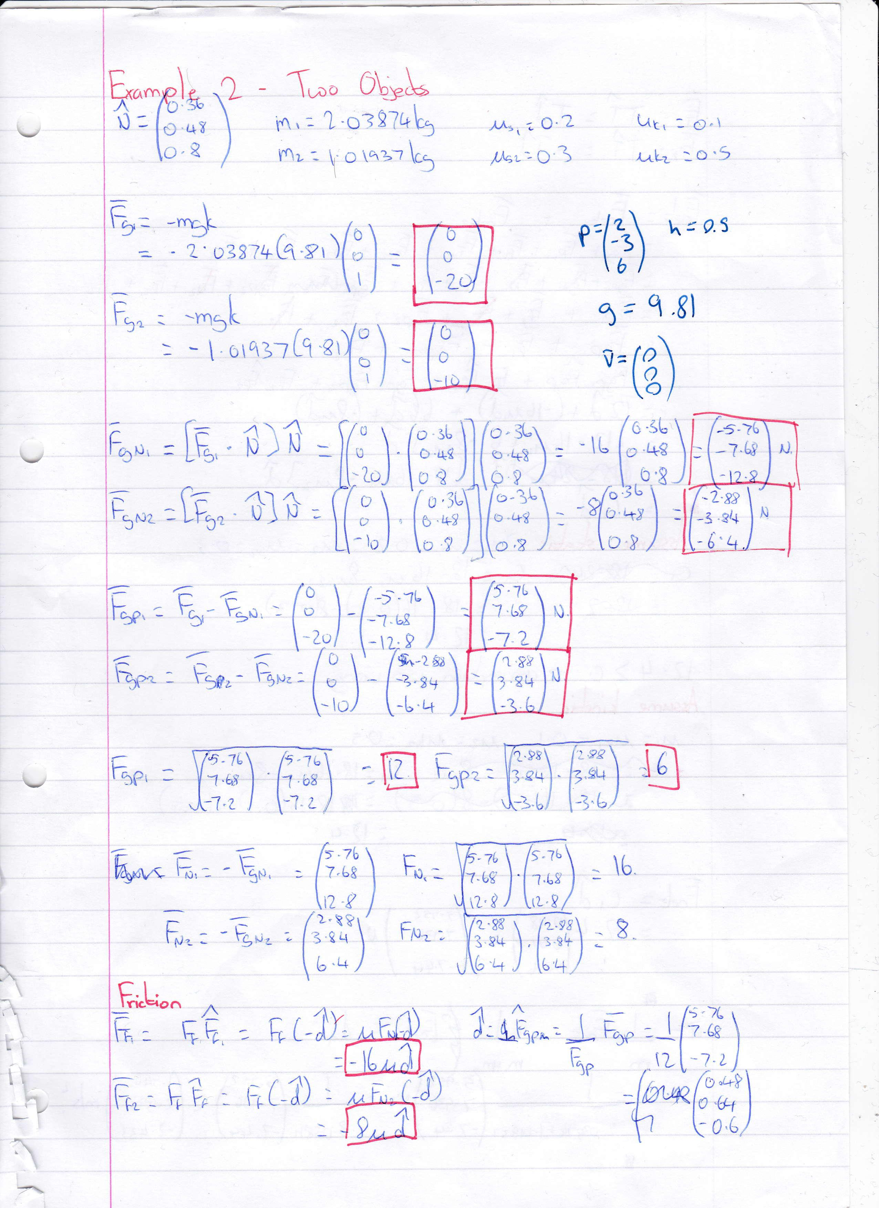**Example 2:**

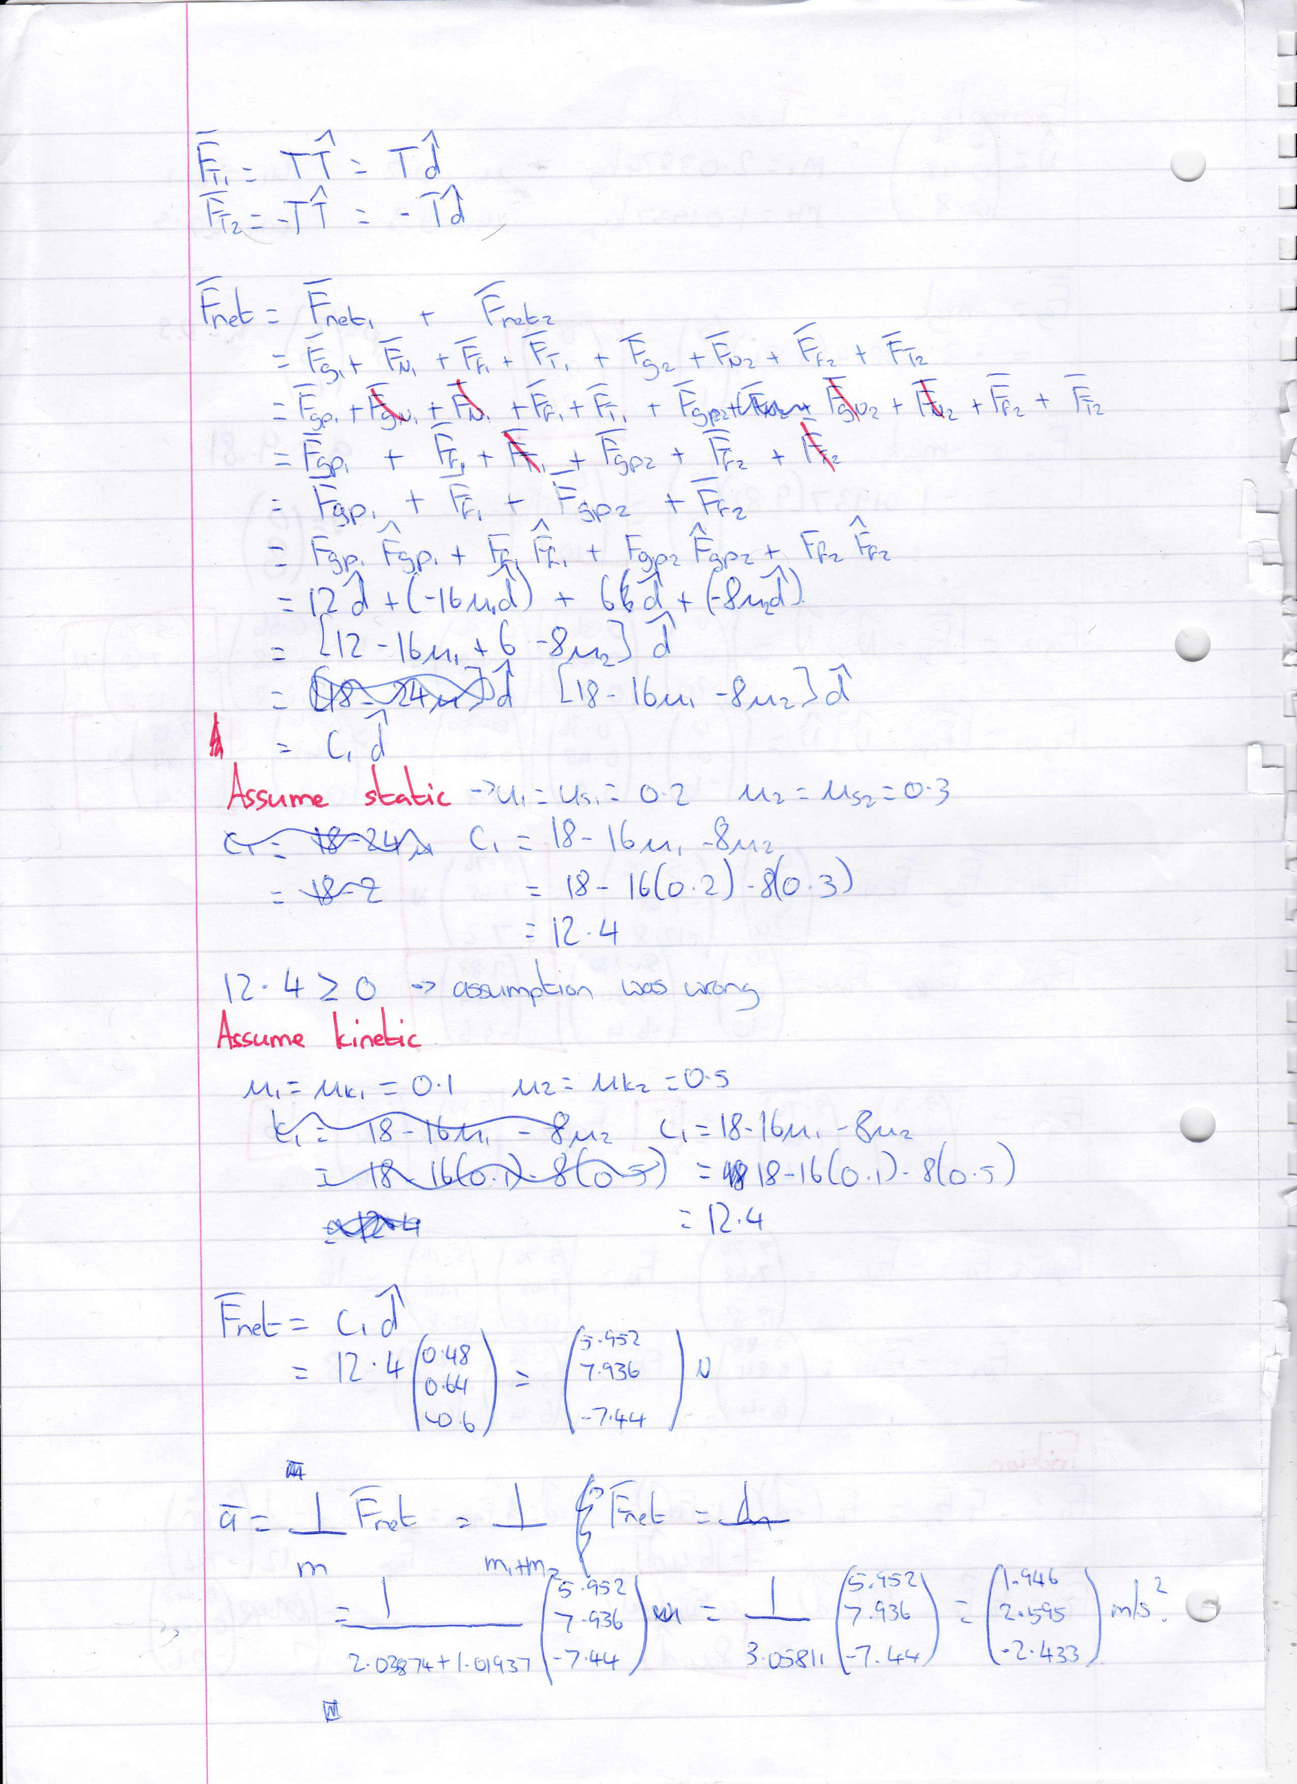

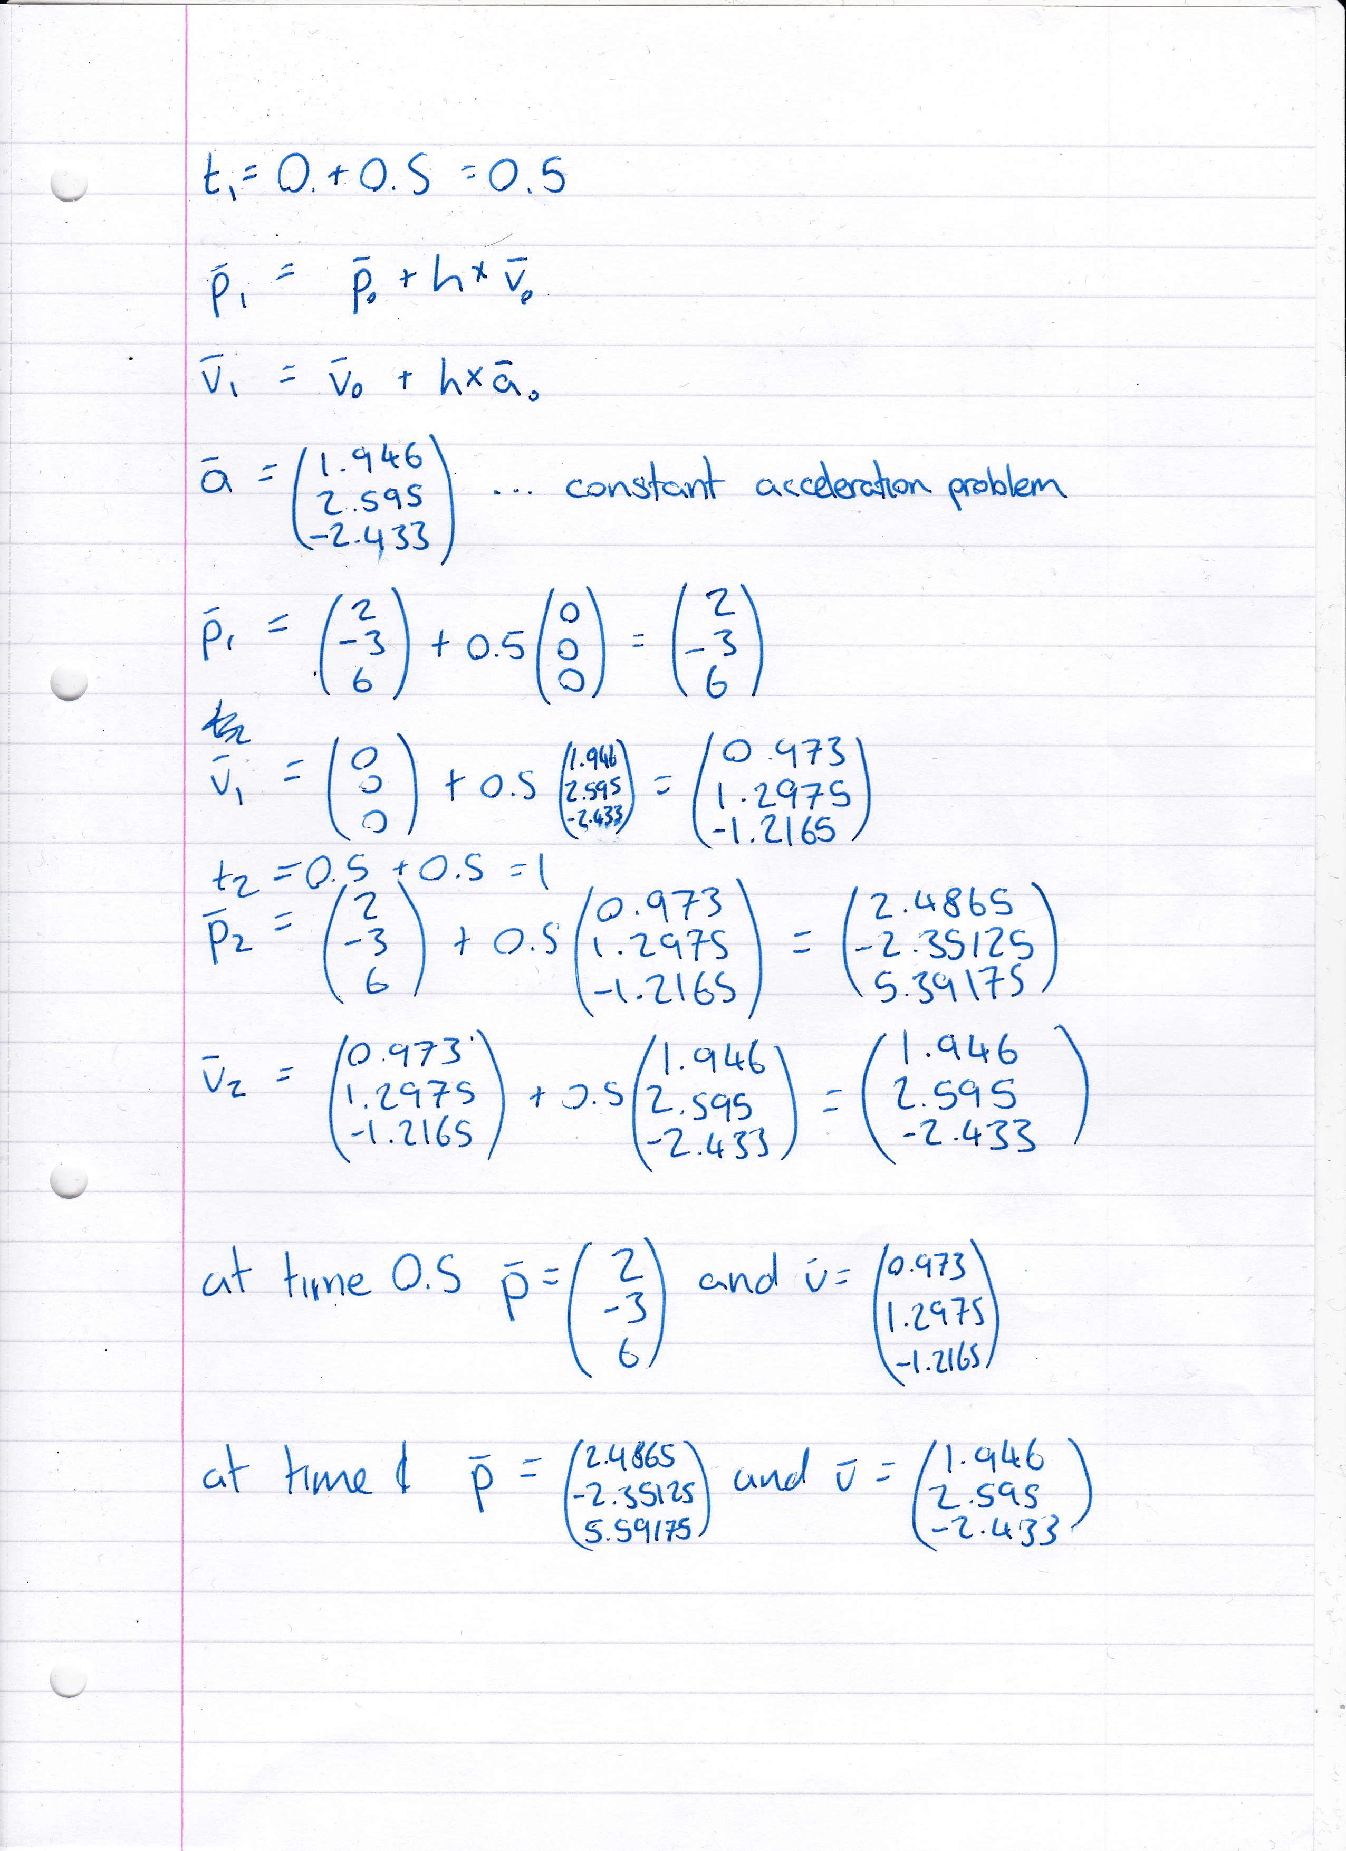

**Example 3:**